Objective Answers:

1. The Data has been cleaned accordingly, with according checks for null mishandled value
2. Using this formula, =VLOOKUP(C2, 'country description'!$A$2:$B$16, 2, FALSE), Have filled up the countries in the original data using the country code.
3. This is the required table asked bifercating restaurants opened distribution by country.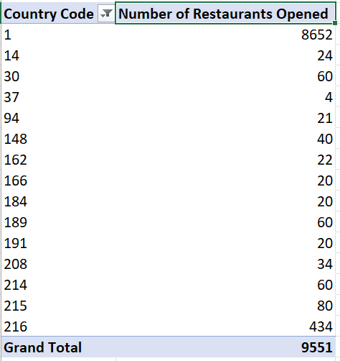
4. This is the something that would be helpful to management, a clear distribution about the restaurants opened each year. 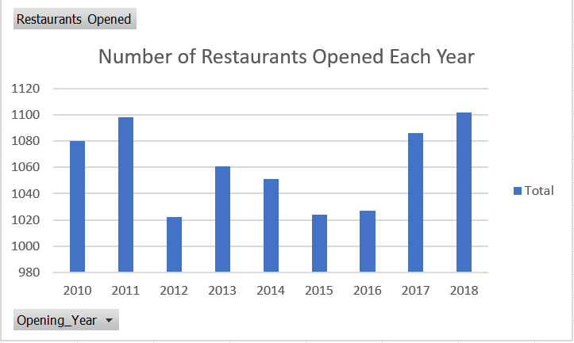
5. There are 2344 restaurants in India in the price range of 4.
6. This table shows the average number of voters for each country. 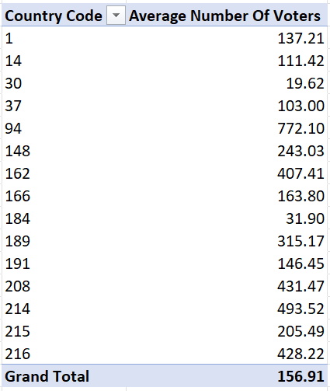

Subjective Questions:

1. To suggest countries where the team can open newer restaurants with lesser competition, we can analyze the data based on the count of restaurants and the average cost for two people. Countries with fewer restaurants and lower average costs for dining out could indicate regions with lesser competition. Based on the provided data, here are some suggestions:
   1. **Canada (Country Code 37)** **:** Only 4 Cities in whole country have only one restaurant each. This indicates potential areas with relatively low competition.
   2. **Australia (Country Code 14) :** This Country has only one restaurant per city where restaurants are charging nominal prices giving a fair and productive opportunity in this market to grow. 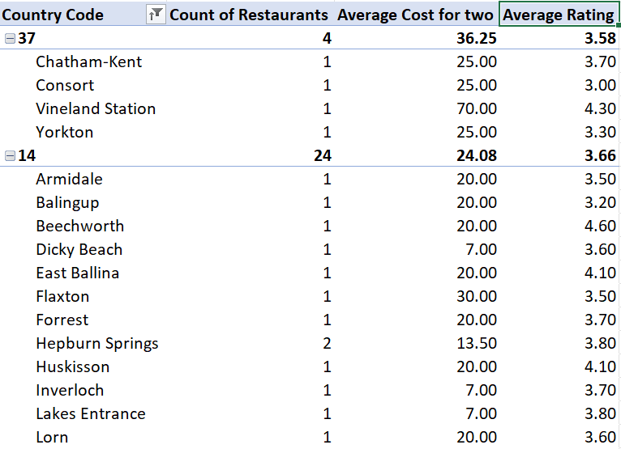
2. Based on the provided data, here are some states and cities within the suggested countries that could be suitable for opening restaurants:

* **A**. **Canada**:
  + Chatham-Kent, Ontario: This city has one restaurant with an average cost for two people of $25.00 and a rating of 3.70.
  + Consort, Alberta: With one restaurant and an average cost for two people of $25.00, Consort presents an opportunity for new restaurant ventures.
  + Vineland Station, Ontario: Vineland Station stands out with one restaurant and a higher average cost for two people of $70.00, along with a high rating of 4.30.
  + Yorkton, Saskatchewan: Yorkton has one restaurant with an average cost for two people of $25.00 and a rating of 3.30.
* **B**. **Australia**:
  + Armidale, New South Wales: Armidale offers one restaurant with an average cost for two people of $20.00 and a rating of 3.50.
  + Balingup, Western Australia: Balingup has one restaurant with an average cost for two people of $20.00 and a rating of 3.20.
  + Beechworth, Victoria: Beechworth stands out with one restaurant and a high rating of 4.60, along with an average cost for two people of $20.00.
  + East Ballina, New South Wales: East Ballina offers one restaurant with an average cost for two people of $20.00 and a rating of 4.10.
  + Flaxton, Queensland: Flaxton presents one restaurant with an average cost for two people of $30.00 and a rating of 3.50.
  + Forrest, Victoria: Forrest has one restaurant with an average cost for two people of $20.00 and a rating of 3.70.
  + Hepburn Springs, Victoria: This city offers two restaurants with an average cost for two people of $13.50 and a rating of 3.80.

These states and cities present opportunities for opening new restaurants based on factors such as the number of existing restaurants, average cost for dining out, and ratings.

1. Based on the provided data, the current quality regarding ratings for restaurants in the suggested countries is as follows:

* Canada (Country Code 37):
  + Average Rating: 3.58
  + Count of Votes: 412
* Notable restaurants and their ratings:
  + Arigato Sushi: 3.30 (26 votes)
  + Consort Restaurant: 3.00 (6 votes)
  + Lake House Restaurant: 4.30 (204 votes)
  + Tokyo Sushi: 3.70 (176 votes)
* Australia (Country Code 14):
  + Average Rating: 3.66
  + Count of Votes: 2674
* Notable restaurants and their ratings:
  + 1918 Bistro & Grill: 4.40 (339 votes)
  + Blue Bean Love Cafe: 3.80 (192 votes)
  + Bridge Road Brewers: 4.60 (237 votes)
  + Mad Cowes Cafe: 3.70 (351 votes)
  + Pig and Whistle: 4.10 (87 votes)
  + The Belle General: 4.10 (56 votes)
  + Vivo Bar and Grill: 4.40 (381 votes)

Overall, the average rating for restaurants in both Canada and Australia is above 3.5, indicating generally positive feedback from customers.

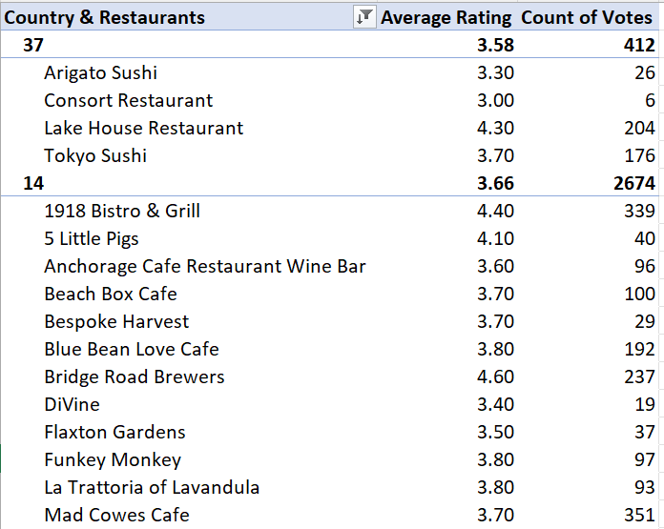

1. The current expenditure on food in the suggested countries varies across different locations. Here's a summary of the average cost for two people in each country:

* Canada (Country Code 37):
  + Average Cost for Two: $36.25
* Australia (Country Code 14):
  + Average Cost for Two: $24.08

These averages provide an overview of the expenditure on food in the suggested countries. However, it's essential to note that there is variation within each country. For example, in Canada, the average cost ranges from $25.00 to $70.00, while in Australia, it ranges from $7.00 to $120.00.

To keep financial expenditure in control, it's crucial to consider the average cost for dining out in specific locations where new restaurants are planned 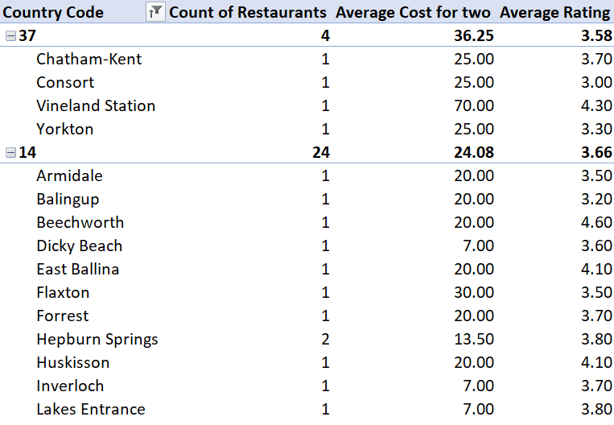

1. We can identify the restaurants from the recommended states that are considered competitors and those rated in the lower brackets (1-2 or 2-3). Here's the breakdown:

Competitors:

* Canada (Country Code 37):
  + Vineland Station: This restaurant stands out with a high rating of 4.30 and an average cost for two of $70.00. It could be considered a competitor due to its high rating and potentially higher-end offerings.

Lower-rated Restaurants (1-2 or 2-3):

* Canada (Country Code 37):
  + Consort: This restaurant has a rating of 3.00, placing it in the lower bracket, with an average cost for two of $25.00.
  + Yorkton: Another restaurant in Canada with a rating of 3.30, falling within the lower bracket, and an average cost for two of $25.00.
* Australia (Country Code 14):
  + Montville: This restaurant has a rating of 2.40, placing it in the lower bracket, with an average cost for two of $30.00.
  + Mayfield: Another restaurant in Australia with a rating of 2.90, falling within the lower bracket, and an average cost for two of $20.00.
  + Paynesville: This restaurant also falls within the lower bracket with a rating of 2.60 and an average cost for two of $120.00.

These restaurants in the lower-rated brackets could be considered as potential opportunities for improvement or differentiation in the market.

1. Based on the provided data, it's evident that certain cuisines consistently receive higher ratings from customers.

These cuisines include:

* Sunda, Indonesian
* World Cuisine
* Italian, Deli
* Italian, Bakery, Continental
* Mexican, American, Healthy Food
* These cuisines, with average ratings of 4.90, are highly appreciated by customers and could be prioritized in newer restaurant ventures to ensure better feedback and customer satisfaction.
* Additionally, it's crucial to note that the choice of cuisines does indeed have a significant impact on restaurant ratings. Cuisines such as Sunda, Indonesian; World Cuisine; and Italian, Deli consistently receive high ratings, indicating a strong correlation between cuisine offerings and customer satisfaction.
* 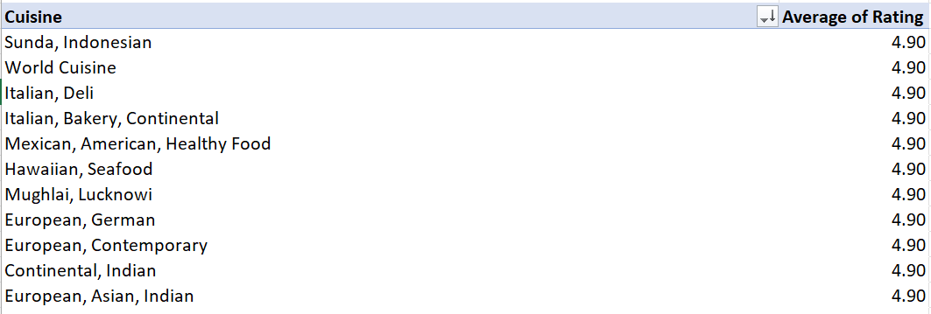

1. It appears that offering both online delivery and table booking services positively influences customer ratings. Restaurants that provide both online delivery and table booking services have an average rating of **3.41**, whereas those that do not offer these services have a lower average rating of **2.75**. This indicates a notable difference in customer satisfaction between the two groups. 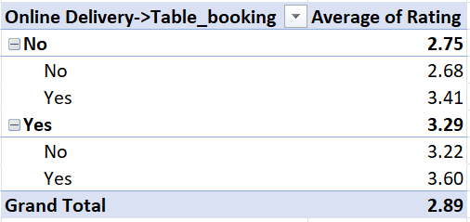
2. There seems to be a correlation between the average rating of cuisines and the feedback received, as indicated by the count of votes. Higher-priced cuisines, on average, tend to receive better feedback in terms of ratings. For instance:

Cuisines in the price range of 4 have the highest average rating of 3.84, followed by cuisines in the price range of 3 with an average rating of 3.71.

As the price range decreases, the average rating also tends to decrease. Cuisines in the price range of 2 have an average rating of 3.07, while those in the price range of 1 have the lowest average rating of 2.38.

Furthermore, considering the count of votes, it appears that higher-priced cuisines receive a comparatively lower number of votes. This suggests that while higher-priced cuisines may receive better feedback in terms of ratings, they might cater to a smaller audience.

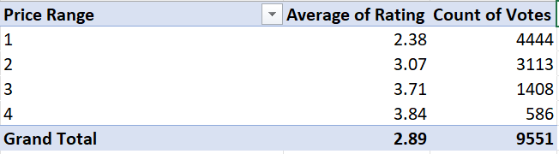

1. This is the distribution for different price ranges in each country entailing bifurcation count for each respective price range. 